How to Provision the SPA525G and SPA504G Phones for NorthWest VoIP
SPA504G
1. Press the settings button on your phone (the one that looks like a page with a corner folded over)
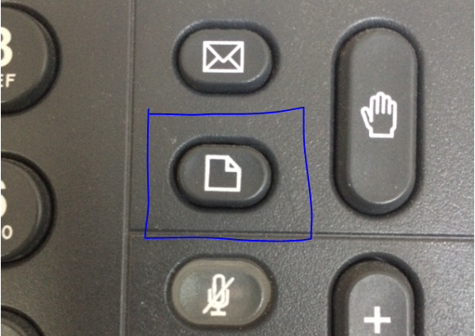
2. Press 9, this should reveal the local IP of the phone. Make a note of it.
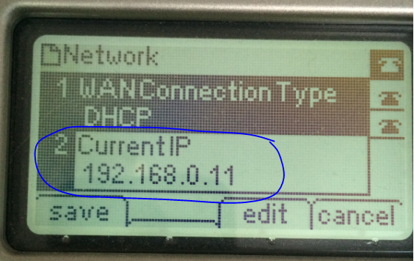
3. Open a browser on a computer on the same network
4. In the address field enter the following: http://<local_IP_Of_Phone>/admin/resync?http://voipcfg.planbcorp.com/initialize.xml
5. Replace <local_IP_Of_Phone> with the IP you made a note of in step 2, and press enter.
6. You should see a screen that’s says your phone is restarting.
7. Your phone may restart twice, and you may have to wait for it to restart. Give it about five minutes to complete the process.

SPA525G
1. Press the settings button on your phone (the one that looks like a page with a corner folded over)

2. Press (or scroll down to) 10 Status and select it
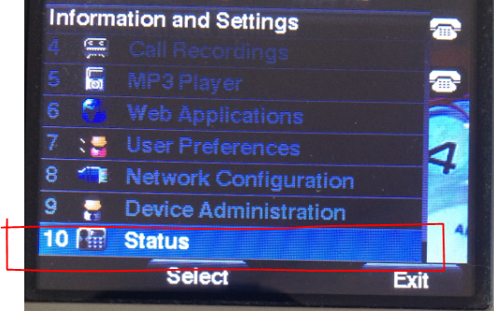
3. Press (or scroll down to) 2 Network Status and select it
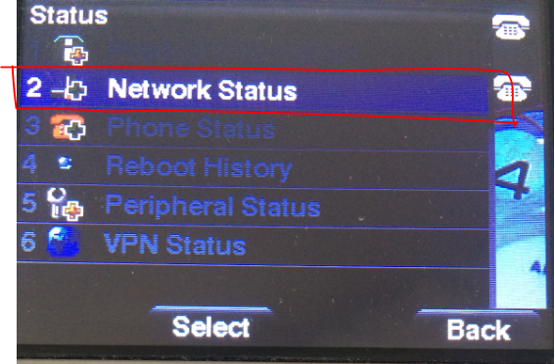

4. Make note of the IP
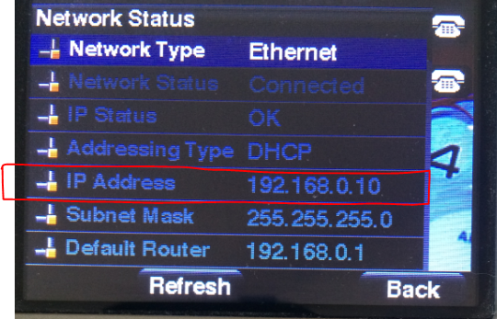
5. Open a browser on a computer on the same network
6. In the address field enter the following: http://<local_IP_Of_Phone>/admin/resync?http://voipcfg.planbcorp.com/initialize.xml
7. Replace <local_IP_Of_Phone> with the IP you made a note of in step 2, and press enter.
8. You should see a screen that’s says your phone is restarting.
9. Your phone may restart twice, and you may have to wait for it to restart. Give it about five minutes to complete the process.

